Maple Leaf Foods Inc
Student’s name
Institution Affiliation
Date of Submission

Maple Leaf Foods Inc
Introduction
Maple Leaf Foods is a Canadian company that leads in consumer-packaged protein, and its headquarters is located in Mississauga, Ontario. This company began in 1961 when Maple leaf Mills was established from the amalgamation of Maple leaf Milling Company Limited, Toronto Elevators Limited and Purity Flour Mills limited. In 1991, Maple Leaf Mills and Canada Packers incorporated and formed Maple Leaf Food Inc. During the outbreak of the Corona Virus pandemic, many companies across the world operated under loss. This mainly impacted production and packaging companies as a result of low production that caused low demand schedule from the consumers.
Although, Maple Leaf Food implemented best practices that prioritized safety of its employees as well as the stability and production of food and supply. In 2020, Maple Leaf Food increased its sales by 9.2% which is $4,303.7 million from the previous year which was $3,941.5 million contributed by a steady growth in the Meat and Plant Protein sectors.
Year | Profit
2019 | $243
2018 | $232
2017 | $211
2016 | $186
2015 | $192
2014 | $190
2013 | $142
2012 | $200
2011 | $193.0
2010 | $ 187.0
AVE | $197.6
2020 | $180.3

In average, 2020 produced a low profit value of $3.30 than other previous years. The impact of the Covid -19 was intense and interfered the the general operation of the company. For instance, in 2020, the gross costs associated with COVID-19 was approximately $58 million. This was comprised of the labour bonuses, purchases of sanitation, screening, personal protective equipment, and testing tools, support for the Company's hog producers, donations to support front-line healthcare workers, emergency food relief efforts and other preventative measures. This was partially offset by reductions in discretionary spend, resulting in a net impact of approximately $42 million to total Company Adjusted EBITDA.
But in segments, there was a superb outcome in Meat Protein which exceeded other incremental costs related to COVID-19 and an increase in variable compensation. The low outcome was also facilitated by the higher loss from the non-cash fair value changes in biological assets, derivative contracts and non-recurring other expenses, which are not included when calculating Adjusted Operating Earnings. Despite the fact that there was low customer turnout due to covid 19, the company recorded a strong commercial performance that contributed to a gross profit of $680.3 million, which was a gross margin of 16.5% when compared to the previous year. Some of the strategies used were expansion of sustainable meat supply centers, favourable mixes and pricing policies implemented to mitigate rate of inflation as well as structural costs.
The SG&A expenses for 2020 was $94.2 million which was 8.7% of sales. The increase in SG&A expenses was primarily facilitated by an increase in variable compensation. As a percentage of sales, SG&A expenses were almost flat in 2020.

Three months ended December 31, 2020 | Three months ended December 31, 2019
($ millions)^{(i)}  (Unaudited) |  | Meat  Protein  Group |  | Plant  Protein  Group | Non-  Allocated^{(ii)} | Total |  | Meat  Protein  Group | Plant  Protein  Group |  |  | Non-  Allocated^{(ii)} | Total
Sales |  | $ | 1,080.3 | 52.5 | (3.6) | $ | 1,129.2 | $ | 970.3 |  | 49.7 | (4.1) | $ |  | 1,016.0
Gross profit |  | $ | 185.7 | 0.3 | (5.7) | $ | 180.3 | $ | 150.5 |  | 7.2 | 3.0 | $ |  | 160.8
Selling, general and administrative  expenses |  | $ | 94.2 | 32.5 | — | $ | 126.8 | $ | 84.0 |  | 45.3 | — |  | $ | 129.3
Adjusted Operating Earnings^{(iii)} |  | $ | 91.5 | (32.3) | — | $ | 59.2 | $ | 66.5 |  | (38.1) | — | $ |  | 28.4
Adjusted EBITDA^{(iii)} |  | $ | 136.5 | (28.7) | 1.3 | $ | 109.1 | $ | 110.2 |  | (34.9) | — | $ |  | 75.3
Adjusted EBITDA margin^{(iii)} |  |  | 12.6 % | (54.7) % | N/A |  | 9.7 % |  | 11.4 % | (70.3) % |  | N/A |  |  | 7.4 %
The figure below shows Maple Leaf experiences during covid 19, especially on demand and supply. There was a decline in supply as well as shares because of low sales and demand of food. Maple leaf was negatively affected just like many other companies across the world, thus experiencing adverse demand and supply shifts. The impact was mainly due to interruptions in foreign and domestic demand, liquidity problems, regulations related to health measures, storage or supply chain problems, and lack of personnel due to the pandemic. Relative to the average response of Maple Leaf, the adverse demand clearly dominates all other factors according to the statistics.
Covid-19 impact and adverse supply and demand shifts
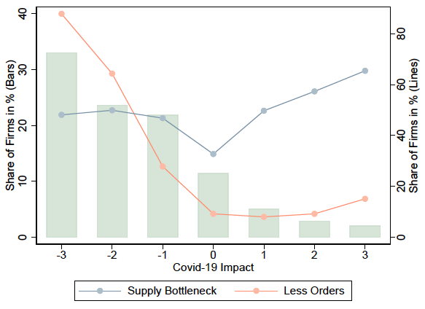
Conclusion
The impact of the COVID-19 pandemic to people, communities, and organizations has been significant. By providing nutrition to people nationally and internationally, Maple Leaf Foods has been designated an essential service. This responsibility does mitigate some of the more significant financial and operational impacts experienced in many other industries, however, the current environment does increase operating costs and the potential for short-term processing shutdowns required to protect the health and safety of plant personnel.

References
Balleer, A., Link, S., Menkhoff, M., & Zorn, P. (2020). Demand or supply? Price adjustment during the Covid-19 pandemic.
https://www.mapleleaffoods.com/downloads/annual-reports/
https://www.mapleleaffoods.com/wp-content/uploads/2017/02/Annual-report-for-SEDAR.pdf
https://www.mapleleaffoods.com/wp-content/uploads/2018/07/2017-Annual-Report.pdf
https://www.statista.com/statistics/196905/revenue-of-the-toronto-maple-leafs-since-2006/
Rude, J. (2020). COVID‐19 and the Canadian cattle/beef sector: Some preliminary analysis. Canadian Journal of Agricultural Economics/Revue canadienne d'agroeconomie, 68(2), 207-213.

